HARVELELECTRIC ELECTRONIC STORE

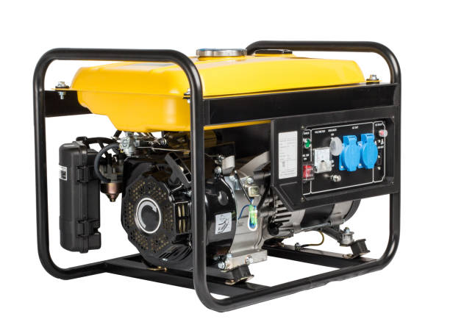

100% Copper Constant 4.5KVA Key Start Generator - SV6800E2

Brand: [Elepaq](https://www.jumia.com.ng/elepaq/)

**Price: $780**

Was ~~$800~~ 54%

+ shipping only for V.V.I.P clients.

## **Product details**

Introducing the powerful Elepaq Constant 4.5KVA Key Start Generator SV6800. This amazing generator adopts an advanced technology in design and performance peculiar only to the Elepaq Brand.

**About the Brand:**  
Elepaq is historically one of the leading generators brand in Nigeria. Over time, Elepaq has established itself as the market leader in the highly dynamic and competitive generator market environment  through a combination of its superior quality and affordability.  Their philosophy is to ensure that all its products are reliable, innovative and affordable.  About the Brand:Elepaq is historically one of the leading generators brand in Nigeria. Over time, Elepaq has established itself as the market leader in the highly dynamic and competitive generator market environment  through a combination of its superior quality and affordability.  Their philosophy is to ensure that all its products are reliable, innovative and affordable.

## **Specifications**

## **KEY FEATURES**

* AC Frequency: 50 Hz
* Starting Capacity: 4.5KVA
* Running Capacity: 4.0KVA
* Voltage Regulation: 220V
* Phase: Single Phase
* Engine Type: 4-stroke single cylinder, OHV, air cooled
* Brush,self exciting, synchronous,2-pole,100% Copper Enameled Wire
* DC Output (Horse power/ KW): 12V/8.3A
* Starting System: Automatic key start
* Fuel: Petrol
* Tyres
* Battery
* Fuel Tank Capacity: 15L
* Noise Level @ 7 Meters: 68 dB
* Dimensions (LxWxH): 715*460*460
* Weight: 55 KG

## **SPECIFICATIONS**

* **SKU**: EL479HL0TDMPFNAFAMZ
* **Product Line**: WAGON
* **Model**: SV6800E2
* **Weight (kg)**: 55
* **Color**: N/A
* **Area of Use**: Outdoor